A LONGER VIEW ON PANDEMICS by TODD GRAY

Our current situation is not unusual, but, because we are the first generation in England which has no memory of suffering a pandemic, it is natural to think that somehow what we are going through is unique. In fact, it is only exceptional to us. Every previous generation, for many centuries, has endured waves of various infectious diseases and the last pandemic, when Spanish Flu overwhelmed society at the end of the Great War, has similarities with today which may be particularly useful to remember.

Hopefully it is reassuring to know that events today are not unique: it has been commonplace for epidemics to not only interrupt the course of everyday life but also result in mass illness and sometimes the sudden loss of many lives. Previous generations lived with this lottery of death whereas we have come to expect modern medicine to overcome new outbreaks of infectious diseases. Anthrax, cholera, diphtheria (or croup), dysentery, influenza, leprosy, malaria, measles, plague, scarlet fever, smallpox, syphilis, tuberculosis, typhoid fever and typhus are some of the infectious diseases which have played a part in English life. Gradually the medical world finds treatment and hopefully cures and vaccines. In 1918 the arrival in Devon of a contagious disease, that of a new form of influenza, caused the closure of some schools and shops in Exeter and across the county. This was initially precipitated by a lack of healthy adults able to work but eventually it was commonplace for schools to close across the county. As the days passed public transport services were curtailed, cinemas were closed to children and soldiers, visitors were barred to military barracks and hospital wards, and public events were cancelled.

One key characteristic of the appearance of any new virus or bacteria is that national or local authorities are baffled in knowing how to act: until a disease’s nature is understood officials can only guess at what actions they need to take to prevent or cure disease. Each disease needs to be understood as to how it is transmitted; does it enter a body’s system through personal contact or via agents such as fleas or lice? Those most at risk also differ. In 1918 it was not initially understood that younger adults, and particularly expectant mothers, were more susceptible to the new form of influenza. Death was often rapid: an individual apparently in good health in the morning could fall ill and die by the evening. It was also not known that the virus would return. There were waves in 1918 and 1919: flu appeared and went away only to unexpectedly come back. The outbreak seemed over but then returned once more. Hundreds of Exonians died in the middle wave but the overall number was substantially increased by the deaths of those local men who were still serving overseas or were convalescing elsewhere in military hospitals. Plymouth had three times the number of deaths which occurred in Exeter.

In 1918 Exonians recalled the earlier outbreak of influenza in 1889-92 as well as the many others throughout the early 1800s.Today some Exonians will recall when flu appeared in 1957-8 (Asian Flu), 1968-9 (Hong Kong Flu) or 1977-8 (Russian Flu). In 1918 some Exonians referred to the events of 1832 when cholera took over the city. Again, it showed that authorities were unprepared because they were ignorant of the nature of cholera. Councillors spent great sums in providing flannel belts which they wrongly believed were a preventative. Local people also took up drinking brandy: this was thought to be a cure if not another way to preempt catching the infection. It was crucial to avoid contaminated water so in one respect the drinking of alcohol would have been advisable. Critics complained that the city was given over to licentiousness but many locals were desperate to stay healthy through any possible means.

In 1832 the streets of central Exeter were abandoned for weeks as all commerce stopped. It was said that the only noise one heard was that of the ringing of funeral bells. Containment and isolation have been standard practices for more than five hundred years because severe outbreaks of disease were commonplace. In the late 1500s plague struck somewhere in Devon every few years while in the 1620s disease became so widespread in one year that Exeter’s mayor fled the city and left it without effective government. The disease caused the economy to collapse and working people threatened to riot unless they were given financial assistance. Fortunately for Exeter, a councillor stepped in and ran the council.

As with other infections, quarantines were commonly used to stop the spread of disease. Barnstaple stopped strangers from entering the town and across Devon pest houses were routinely set up to separate those who were ill from people who remained healthy. At this time it was standard for some ten per cent of a village or town’s population to die in an outbreak.

A considerable number of diseases passed through Devon during the Civil War in the 1640s including the Sweating Sickness at Tiverton. Nearly 450 died in that town in 1644.The highest proportion of Devon deaths from one outbreak of disease has long been thought to have occurred from 1347 to 1351 when the Black Death probably removed as much as half the population.

Research has been crucial in society being able to learn how to overcome infectious disease: twenty years after cholera struck Exeter in 1832 it was proved that unclean water was the carrier of infection. By then Exeter had overhauled its sanitation and water supplies. The next national cholera outbreak was inconsequential in the city. Syphilis was another disease which spread through Europe in the sixteenth century but it took centuries for an effective treatment to be found.

Uncertainty about the reasons for infection caused Devonians in the 1500s and 1600s to constantly question whether it was divine intervention that caused plague to hit one village but spare all those others near it. Many Devonians today will remember this was the way in which some people talked about HIV in the 1980s. Fear, panic and despair were also the natural consequences of other epidemics in which sudden death became commonplace. In the early 1600s an Okehampton man was discovered in Crediton having succumbed to plague: he was surreptitiously removed from Crediton in the dead of night, placed on a horse and returned to Okehampton where he was cast into the gutter. In 1918 one young Devon woman threw herself out of an upstairs window after contracting flu. That year local people were shocked by reports of `alarming proportions’ of the populations of towns being ill. Hundreds of years earlier, during an outbreak of plague, it was rumoured across Devon that a `vision’ of a funeral cortege had been seen one night passing through Newton Ferrers near Plymouth. Local people followed it to the church where the mourners and corpse disappeared but left behind a newly dug grave. The ghostly mourners then assembled at the ferry where the ferryman fell ill and died. The human response to each outbreak of disease has been, naturally, to fall back upon what they had learned from other epidemics: minimize contact with people to avoid becoming ill.

One consequence of the cholera epidemic of 1832 was that society was unprepared for the disposal of the large number of bodies. Riots broke out in St David’s in Exeter when a corpse was brought for burial in the public park now known as Bury Meadow. On occasions local people felt that corpses were not given the dignity that they deserved: coffins were being carried under-hand instead of on the shoulders of the bearers. In one instance a riot took place when it was believed infected people had been placed in coffins before their deaths. Likewise, unease was felt when the corpse of a `very large bulky woman’ was forced into her too-small coffin, but perhaps the most troubling incident was reported by an undertaker: he witnessed a body having muscle spasms after death and it was problematic to place the corpse into its coffin

The main difference today is that we have learned about the nature of each disease. Unfortunately, the speed of travel makes it more difficult to deal with any outbreak. Each day many thousands of people arrive in Devon having travelled considerable distances to get here. Many have come from the other side of the world. Devonians had watched cholera take five years to travel from India to England. It finally arrived in Sunderland in 1831, moved south towards London and months later it arrived in Exeter via a woman who caught it in Plymouth.

Historically, Exeter was less at risk of infectious disease than Plymouth where naval ships were often the carriers of infection. However, in 1586 Portuguese prisoners at the county courthouse at Rougemont Castle in Exeter transmitted disease to their judges: they caught `gaol fever’, what we know as typhus, and it then spread throughout Exeter. The prisoners had been kept in filthy conditions (the `filthy stink... of the stinking dungeon’) and the typhus bacteria spread through the bites of the men’s lice and fleas. Today we have a much more immediate possibility of catching disease: a person infected in any part of the world can bring it with them to any part of Devon the following day.

Society in 2020 will learn what previous generations understood: preventing the spread of infections requires a practical approach in avoiding the risk of contamination. Perhaps the most obvious lesson each generation has learned is in taking responsibility for one’s own health and in remembering our own well- being depends upon collective action. As one local man said in 1918 `it was the duty of everyone in the initial stages of the disease to go to bed and isolate themselves’. This remains true a century later. What is also true is that after each outbreak society emerges better-informed and more capable of confronting the next threat

Devon History Society: Newsletter Lockdown Edition [Devon History News]
April 2020
© 2020 Devon History Society

Abbotskerswell was not immune to these outbreaks.

ALFRED ROWE of Mount Pleasant Cottages died on 22nd October 1918 when “he contracted a chill which brought about the complications which caused his death” so it was noted in his obituary. Those complications were Spanish Flu.
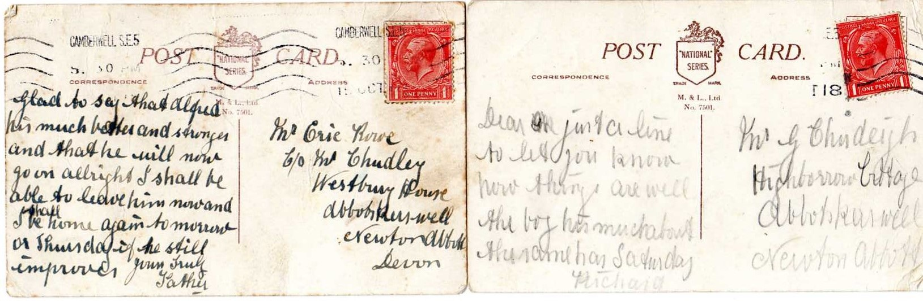

Alfred’s father, Richard, went up to London to be with his sick son and sent these post cards home. The family had already lost another son, Bert killed in 1916.

THOMAS SANDFORD who lived at Odle Hill Cottage died on 13th October 1918 and as his death certificate below shows, he too had Spanish Flu.

Earlier in the village’s history two of our vicars, John Huchon and William de Bokbourne may well have been victims of bubonic plague outbreaks when they died in 1349 and 1361 respectively.

